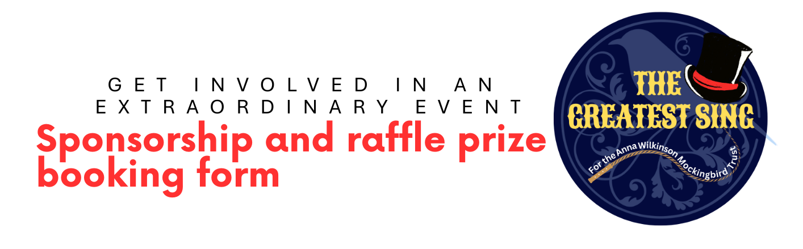
Name: |  | Phone:
Company name: |  | Email:

Sponsor a seat at the event - £10 per seat (Please make payment on booking)
Number of seats required :
Name/s to be included on seats:
Sponsor The Greatest Sing pens - £500 (Please make payment on booking)
Name or company name to be thanked:
Bronze sponsor - £500 (Please make payment on booking)
Name or company name to be thanked:
Sponsor the room decorations and hosts’ costumes - £1,000 (Please make payment on booking)
Name or company name to be thanked:
Sponsor The Greatest Sing event programme - £1,500 (Please make payment on booking)
Name or company name to be thanked:

Sponsor The Greatest Sing T Shirt - £2,500 (Please don’t make payment - we’ll be in touch)
Name or company name to be featured:
What does the company do?

Silver sponsor - £2,500 (Please don’t make payment - we’ll be in touch)
Name or company name to be included:
What does the company do?

Gold sponsor - £5,000 (Please don’t make payment - we’ll be in touch)
Name or company name to be included:
What does the company do?

RAFFLE PRIZES
Please let us know what raffle prizes you can provide. Please ensure you have added your contact details at the start of this form. Thank you!

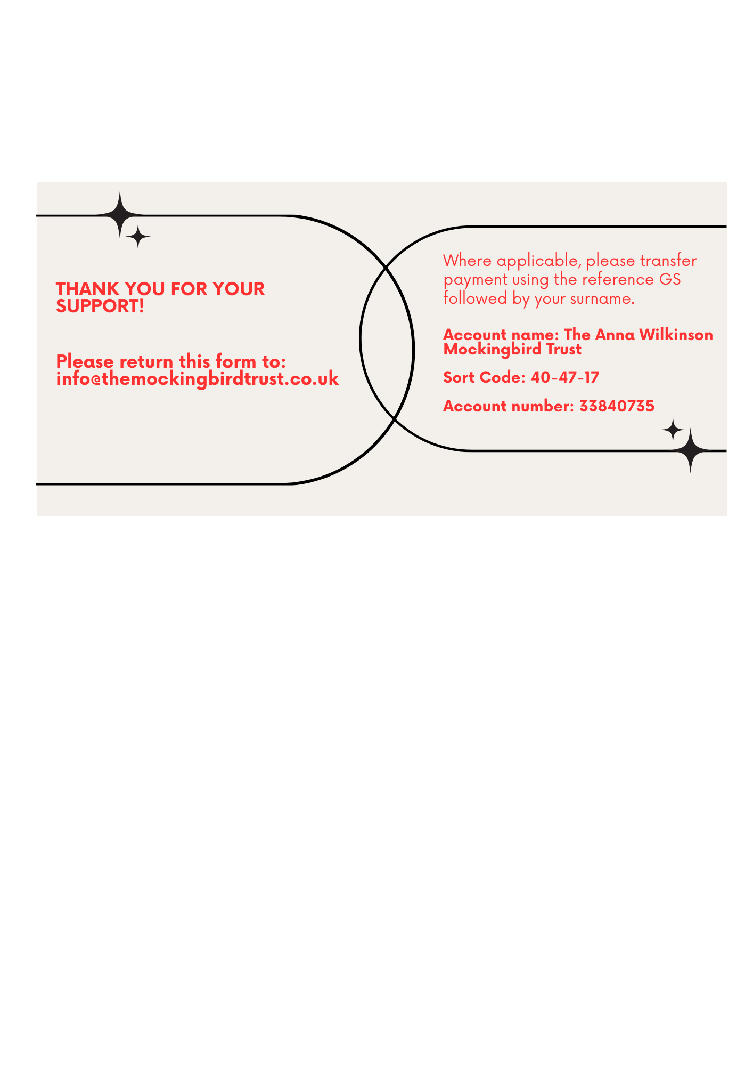

www.TheAnnaWilkinsonMockingbirdTrust.co.uk

