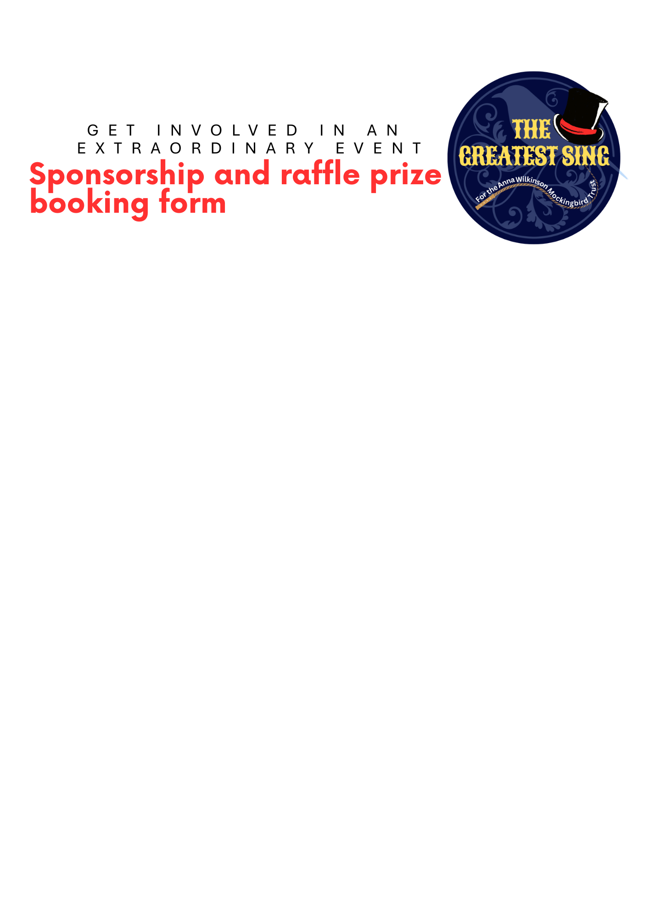

|  |  |  |  |
| --- | --- | --- | --- |
| **Name:** |  | **Phone:** |  |
| **Company name:** |  | **Email:** |  |

|  |
| --- |
| **Sponsor a seat at the event - £10 per seat *(Please make payment on booking)*** |
| Number of seats required : |
| Name/s to be included on seats: |
| **‘Thank you’ in the programme - £100 *(Please make payment on booking)*** |
| Name or company name to be thanked: |
|  |
| **Sponsor The Greatest Sing badges - £300 *(Please make payment on booking)*** |
| Name or company name to be thanked: |
|  |
| **Sponsor The Greatest Sing pens - £500 *(Please make payment on booking)*** |
| Name or company name to be thanked: |
|  |
| **Bronze sponsor - £500 *(Please make payment on booking)*** |
| Name or company name to be thanked: |
|  |
| **Sponsor the room decorations and hosts*’ costumes - £1,000 (Please make payment on booking)*** |
| Name or company name to be thanked: |
|  |
|  |
| **Sponsor The Greatest Sing event programme - £1,500 *(Please make payment on booking)*** |
| Name or company name to be thanked: |
|  |

|  |
| --- |
| **Sponsor The Greatest Sing T Shirt - £2,500 *(Please don’t make payment - we’ll be in touch)*** |
| Name or company name to be featured: |
| What does the company do? |

|  |
| --- |
| **Silver sponsor - £2,500 *(Please don’t make payment - we’ll be in touch)*** |
| Name or company name to be included: |
| What does the company do? |

|  |
| --- |
| **Gold sponsor - £5,000 *(Please don’t make payment - we’ll be in touch)*** |
| Name or company name to be included: |
| What does the company do? |

|  |
| --- |
| **RAFFLE PRIZES** |
| Please let us know what raffle prizes you can provide. Please ensure you have added your contact details at the start of this form. Thank you! |
|  |
|  |
|  |

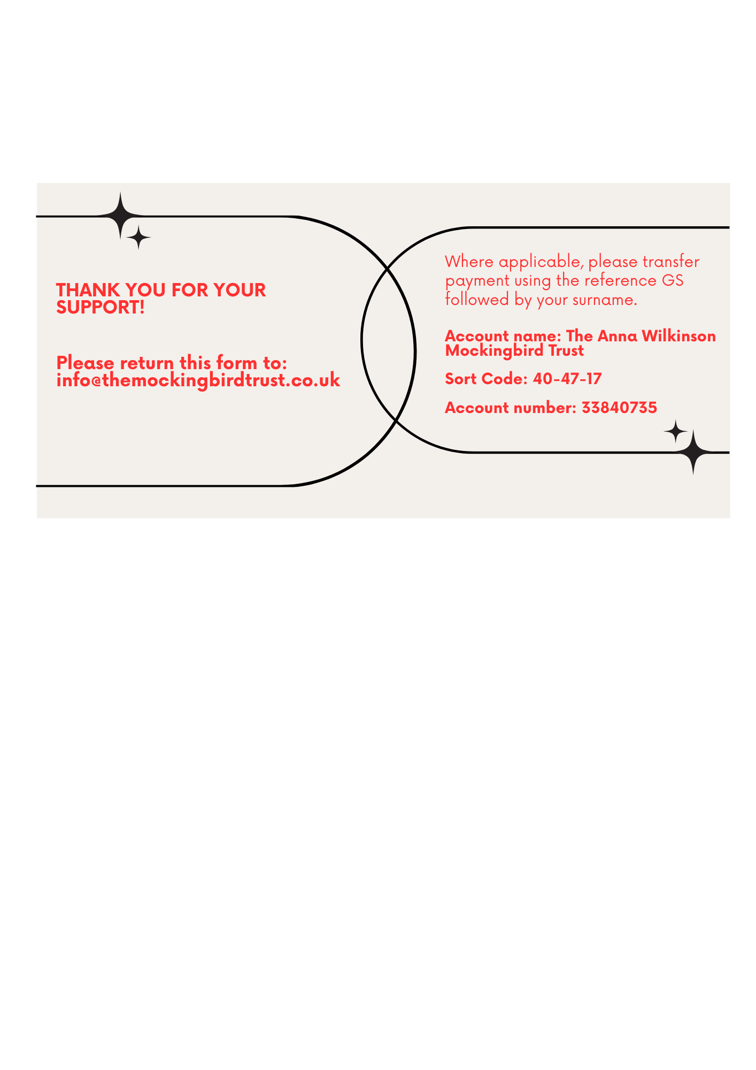

[www.TheAnnaWilkinsonMockingbirdTrust.co.uk](http://www.theannawilkinsonmockingbirdtrust.co.uk)